Key-Value Data Model

🗝️ What is the Key-Value Data Model?
# Source: AI Source: Provided by: [Data Path: Persons Table -> ID Column: 1, Name_En Column: Motasem Essam] -> From: [ChatGPT] on [6/10/2026]
The Key-Value Model is a NoSQL data model where data is stored as a simple pair:
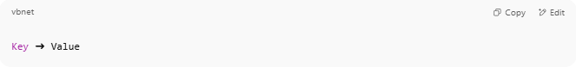
Key ➜ Value

It’s like a dictionary or hashmap:
You use the key to quickly retrieve the value.

🧠 Key Concepts
# Source: AI Source: Provided by: [Data Path: Persons Table -> ID Column: 1, Name_En Column: Motasem Essam] -> From: [ChatGPT] on [6/10/2026]
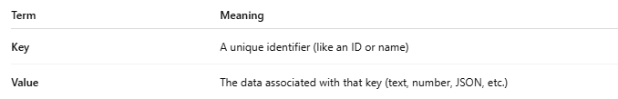
Term | Meaning
Key | A unique identifier (like an ID or name)
Value | The data associated with that key (text, number, JSON, etc.)
⚡ You cannot query by value — you must know the key.

📦 Example: Student Records in Key-Value Model
# Source: AI Source: Provided by: [Data Path: Persons Table -> ID Column: 1, Name_En Column: Motasem Essam] -> From: [ChatGPT] on [6/10/2026]
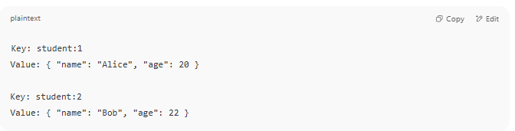
Key: student:1
Value: { "name": "Alice", "age": 20 }

Key: student:2
Value: { "name": "Bob", "age": 22 }

You retrieve a student's info like:

GET student:1

✅ Advantages
# Source: AI Source: Provided by: [Data Path: Persons Table -> ID Column: 1, Name_En Column: Motasem Essam] -> From: [ChatGPT] on [6/10/2026]
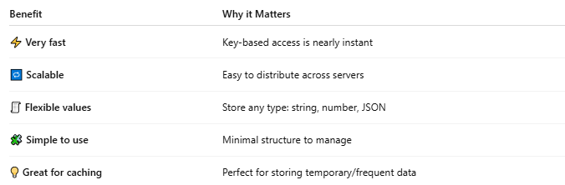
Benefit | Why it Matters
⚡ Very fast | Key-based access is nearly instant
🔁 Scalable | Easy to distribute across servers
🧾 Flexible values | Store any type: string, number, JSON
🧩 Simple to use | Minimal structure to manage
💡 Great for caching | Perfect for storing temporary/frequent data

❌ Disadvantages
# Source: AI Source: Provided by: [Data Path: Persons Table -> ID Column: 1, Name_En Column: Motasem Essam] -> From: [ChatGPT] on [6/10/2026]
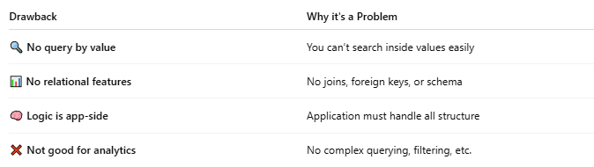
Drawback | Why it's a Problem
🔍 No query by value | You can’t search inside values easily
📊 No relational features | No joins, foreign keys, or schema
🧠 Logic is app-side | Application must handle all structure
❌ Not good for analytics | No complex querying, filtering, etc.

🧰 Examples of Key-Value Stores
# Source: AI Source: Provided by: [Data Path: Persons Table -> ID Column: 1, Name_En Column: Motasem Essam] -> From: [ChatGPT] on [6/10/2026]
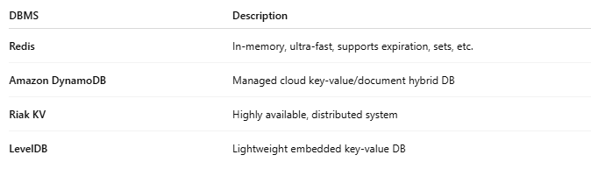
DBMS | Description
Redis | In-memory, ultra-fast, supports expiration, sets, etc.
Amazon DynamoDB | Managed cloud key-value/document hybrid DB
Riak KV | Highly available, distributed system
LevelDB | Lightweight embedded key-value DB

🧾 Real-Life Use Cases
# Source: AI Source: Provided by: [Data Path: Persons Table -> ID Column: 1, Name_En Column: Motasem Essam] -> From: [ChatGPT] on [6/10/2026]
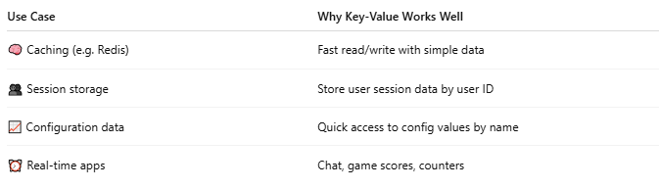
Use Case | Why Key-Value Works Well
🧠 Caching (e.g. Redis) | Fast read/write with simple data
👥 Session storage | Store user session data by user ID
📈 Configuration data | Quick access to config values by name
⏰ Real-time apps | Chat, game scores, counters

🔁 Comparison to Other Models
# Source: AI Source: Provided by: [Data Path: Persons Table -> ID Column: 1, Name_En Column: Motasem Essam] -> From: [ChatGPT] on [6/10/2026]
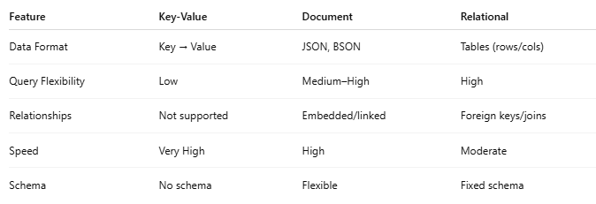
Feature | Key-Value | Document | Relational
Data Format | Key → Value | JSON, BSON | Tables (rows/cols)
Query Flexibility | Low | Medium–High | High
Relationships | Not supported | Embedded/linked | Foreign keys/joins
Speed | Very High | High | Moderate
Schema | No schema | Flexible | Fixed schema

🧠 Summary
# Source: AI Source: Provided by: [Data Path: Persons Table -> ID Column: 1, Name_En Column: Motasem Essam] -> From: [ChatGPT] on [6/10/2026]
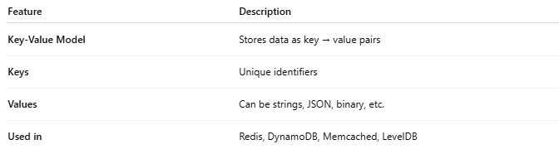
Feature | Description
Key-Value Model | Stores data as key → value pairs
Keys | Unique identifiers
Values | Can be strings, JSON, binary, etc.
Used in | Redis, DynamoDB, Memcached, LevelDB

